**Power BI –**

**Assignment by Muhammad Saqib**

**Dated: 28th December 2021**

**1: Create new queries to connect to the (AdventureWorks_Product_Categories) and (AdventureWorks_Product_Subcategories)**

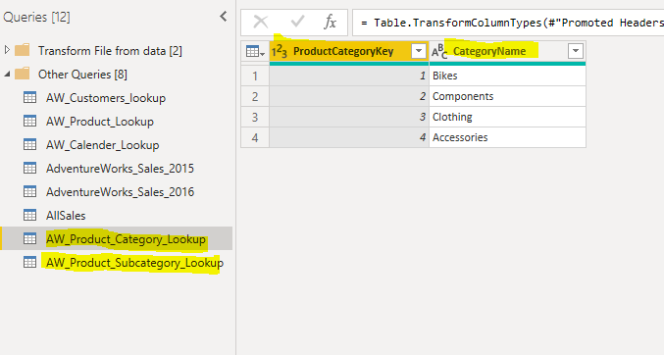

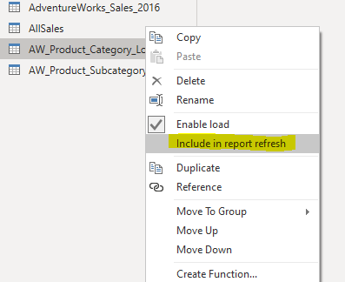

**2: Exercise : Connecting & Shaping Data with Power BI Desktop**

* Add a calculated column that extracts all characters before the dash ("-") in the ProductSKU column, named "SKUType"

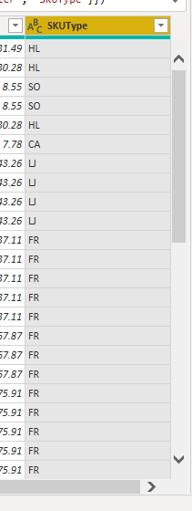

* **Update the SKUType calculation above to return all characters before second dash, instead of the first**

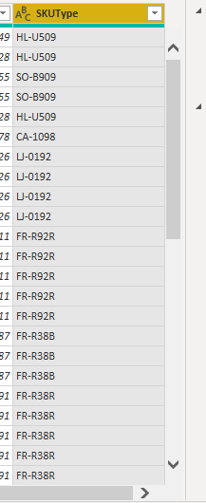

* **Replace zeros (0) in the ProductStyle column with "NA"**

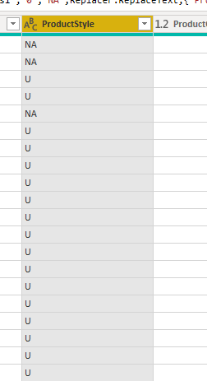

* **Update the DiscountPrice calculation to 15%, by multiplying the ProductPrice values by 0.85 (instead of 0.9)**

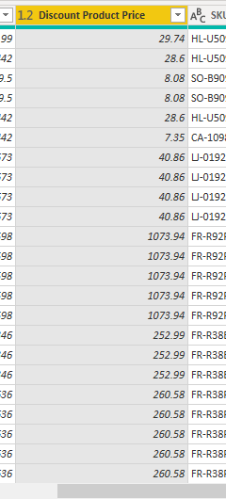

**Exercise : Connecting & Shaping Data with Power BI Desktop**

**Using the Statistics tools in the Query Editor, confirm the following values :**

* **Average product cost ($413.66)**

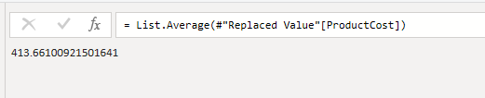

* **Number of distinct product colors (10)**

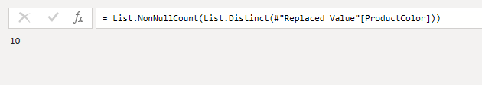

* **Number of distinct customer names (18,110)**

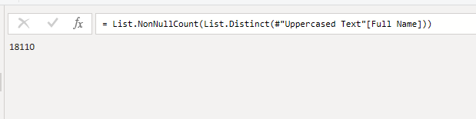

* **Maximum annual customer income ($170,000)**

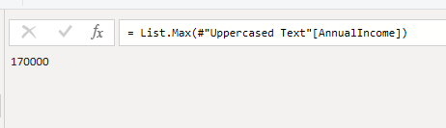

* **Count of order numbers (56,046)**

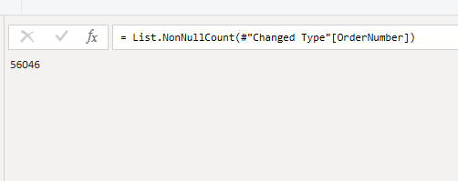

* **Count of distinct order numbers (25,164**

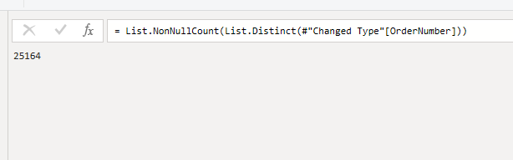

**4) Make the following modifications to the AW_Customer_Lookup query:**

* **Add a new calculated column for the year of birth (named "BirthYear"), based on BirthDate**

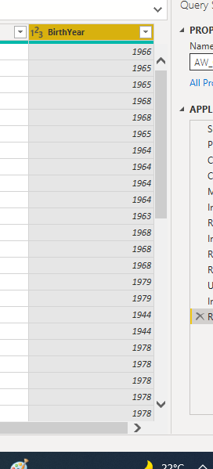

* **Add a conditional column to categorize customer income (named "IncomeLevel"), based on the following criteria : • If AnnualIncome >= $150,000, then IncomeLevel = "Very High" • If AnnualIncome >= $100,000, then IncomeLevel = "High" • If AnnualIncome >= $50,000, then IncomeLevel = "Average" • Otherwise IncomeLevel = "Low"**

